**S. t. u. s. m’s**

**sangola College, sangola**

**A**

**Project Report**

**On**

**“Library management system”**

**submitted in Partial Fulfillment Of The**

**requirement Of The**

**Graduation Course Of**

**B.Sc.(Entire Computer Science)-III**

**2018-2019.**

**submitted by**

**Mr.Ingole V.V.**

**Mr. Ekamalli R.T.**

**Of**

**Sangola College, Sangola**

**Guided By**

Prof. Patil S.V.

**S. t. u. s. m’s**

**sangolaCollege, sangola**



***Certificate***

**Seat No. : - Date:**

**This is certify that Mr. Ingole Vivek Vilas and Mr. Ekamalli Rohit Tanaji completed the project titled “Library Management System” in satisfactory manner as a partial fulfillment for the course of B.sc.(ECS)-III for the session 2018-2019 of the University of solapur.**

***[Project Guide] [Head of Department]***

**Acknowledgement**

Before starting to project report we have to thanks to

**Dept. Of Computer Science**

For giving us to change to present ourselves with great potential and for providing us glorious platform towards our future career.

It gives me great pleasure to remain deeply inspected to our

Project guide Prof. Patil S.V Under whose guidance we completed the project.

The faith and confidence shown by him in our boosted our moral and motivated us to perform better in preparing this project.

We are thankful to all staff members for their valuable suggestion in completing this work.

We are also thankful to my all friends who help me directly or indirectly to carry this project successfully. Thanks must finally to our family especially to our parents, who are always with us.

**Mr. Ingole Vivek**

**Mr. Ekamalli Rohit**

*Index*

|  |  |  |
| --- | --- | --- |
| NO. | Topic | Page No. |
| 1. | Synopsys | **5** |
| 2. | System Concept | **6 - 7** |
| 3. | System Requirements | **8** |
| 4. | System Design | **9** |
| 5. | Table Design | **10 - 14** |
| 6. | User Manual | **15** |
| 7. | Directory Structure   * System * Source code | **16** |
| 8. | User Interface (Screen-shots) | **17 – 26** |
| 9. | Source Code | **27** |
| 10. | Output | **28** |
| 11. | Advantages | **29** |
| 12. | Limitation | **30** |
| 13. | Future Enhancement | **31** |
| 14. | Bibliography | **32** |

S.T.U.S.Mandal’s

SangolaCollage,Sangola

T.Y.B.Sc.(E.C.S)Project

Academic Year 2018-19

***Synopsis***

**Submission Date:** 01-03-2019

**Project Title**:”Library Management System ”.

**Team member:**

1)Mr. Ingole Vivek

2)Mr. Ekamalli Rohit

**Description:-**

In this project we implement all basic library function as well as we try to introduce some extra features from our side.

**System Implementation:-**

1. Languages used :

Front end :JavaFX, FXMl, CSS.

Back end : SQLite

1. Tool’s used :
2. NetbeansIDE : To develop project coding part.
3. Scene Builder : To make UI (user interface) screens.
4. SQLite database manager : To make database design.
5. Launch 4J : To build project .exe file.
6. Install creator pro : To make installer.
7. Barcode to PC scanner : to scan barcode.

**Reasons for selecting this system:**

Because in existing system librarian has to write all the entries (book, student, transtion) manually. This is risky task as some times librarian maintain incorrect data. So for that we want to introduce system that manage all this functioning.

*System Concept*

1. This system has basic library features like add book, issue/submit/renew book, add student, calculate fine, etc.
2. We can also create multiple users as per requirements as well as we can assign permissions to each user.it provides total 14 different permissions to assign. These permissions are as follows.

“Add book, Edit book, delete book, issue book, submit book, add user, edit user, delete user, add member, edit member, delete member, view, setting, all”.

1. Barcode scanning technique is implemented to improve the searching performance of the system. By using barcode scanning we can search any book, user or member within constant time
2. Email notification is used to alert the system members when defined event occur. Events that defined in system are as follows:

If member issue new book then system send email notification with all details like date, time, book name, last submission date, etc.

If member submit/renew book then also system send email notification about their current fine, total fine, date, time, book name, etc.

It also sent alert notification before day of book submission, and after each week when the book submission date ispassed with detailed fine structure.

We can also use this feature to announcement for any function or any give any message to all members.

1. This system automatically generate unique barcode number and ID card. This ID card contains college logo, member photo, college title, their details, with barcode printed on it. We can use this ID card at the time of issue or submit the book.
2. When we have to work with large data then importing of excel sheet is also supported. Within single click we can add hundreds of book or member at a time.
3. It provides 3 password recovery methods to recover password if any user forget. This methods are as follows.

By using security question

By using admin password

By using OTP verification through email

*System Requirements*

To propose this system and display the output of proposed system we use the JavaFX technology.

**Proposed Software Platform:**

* Windows Operating system
* Min jre 1.8 are installed.

**System Requirements:**

* Min jre 1.8 are installed.
* Barcode Scanner.
* printer

**Input To The System:**

* All information related to books, user, members, admin, college.
* Issue / submit date.

**Output From The System:**

* Various kind of reports like fine, issued books, available books, member work ,etc.

*System Design*

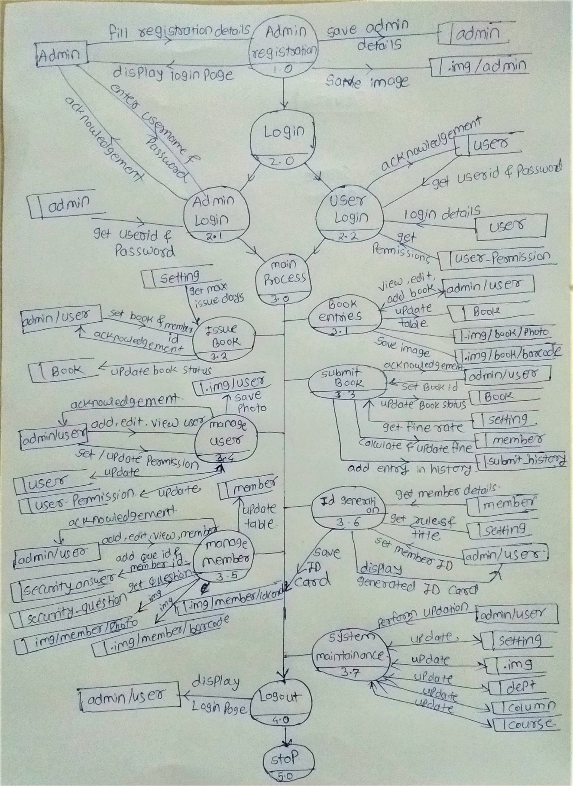

*Table Design*

**Admin :**

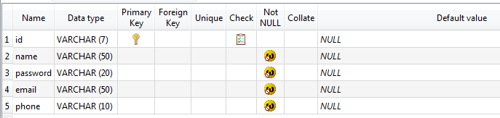

**Book :**

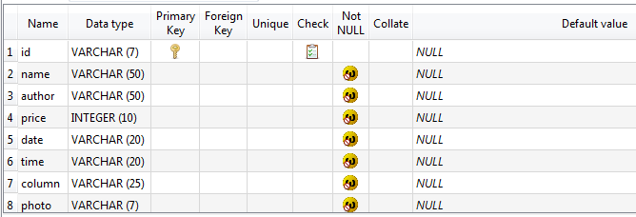

**Column :**

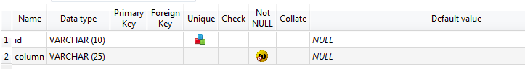

**Course :**

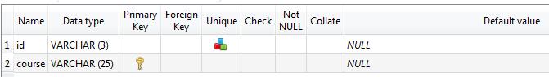

**Dept :**

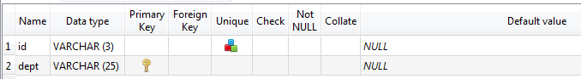

**Issue_Book :**

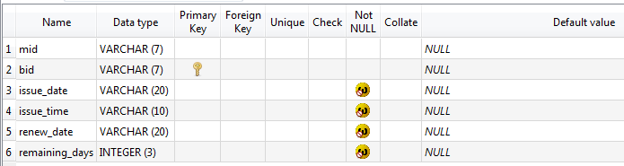

**Log :**

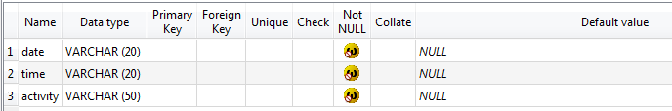

**Security_answer :**

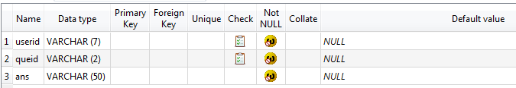

**Security_question :**

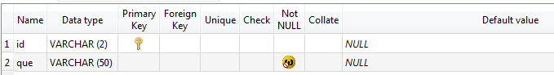

**Member :**

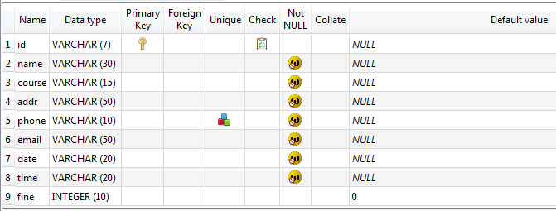

**Setting :**

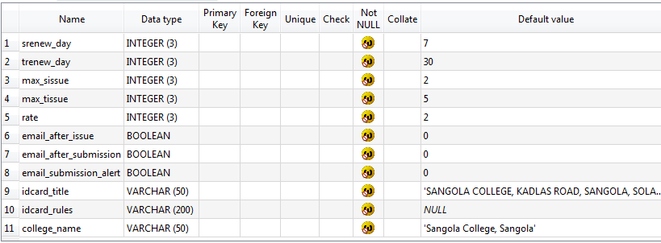

**Submit_history :**

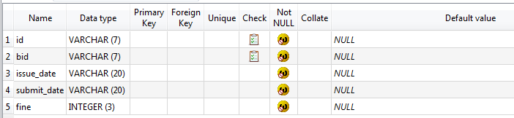

**User :**

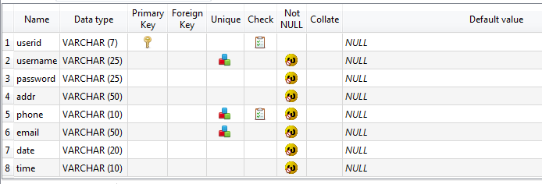

**User_permission :**

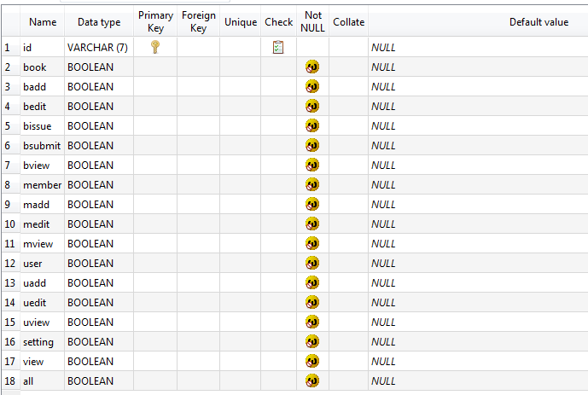

*User Manual*

* first check is there jre 1.8 is installed or not. If not then install it.
* After jre installation install our software by double clicking on it.
* Then you will see .exe file name Library system. Then click on it your system will run.
* If you first time open the system then complete admin registration process first.
* In project folder you will see directory named “img” in this directory all images related to student, teacher, user, books as well as their barcode are stored.
* In img directory you also get automated generated member id’s so you can this images as your need.

Note :-

* Don’t be try to cut, edit or rename any file or folder related to system. Otherwise your system may crash.
* You can copy any files but don’t be delete it.
* In such situation if there will any issue related to system you can directly contact our support team, which is available in first page of the system.

*Directory Structure*

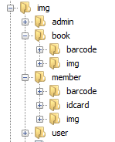



System Database

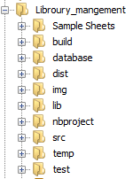

Used to store external system images

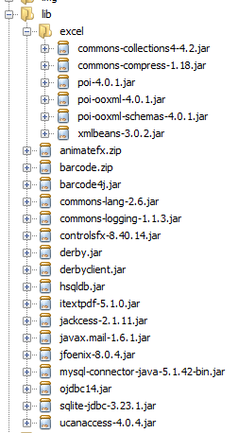

Required library files that must be include.

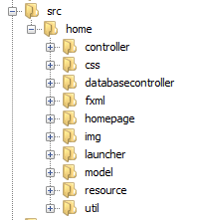

Source Code

*User Interface*

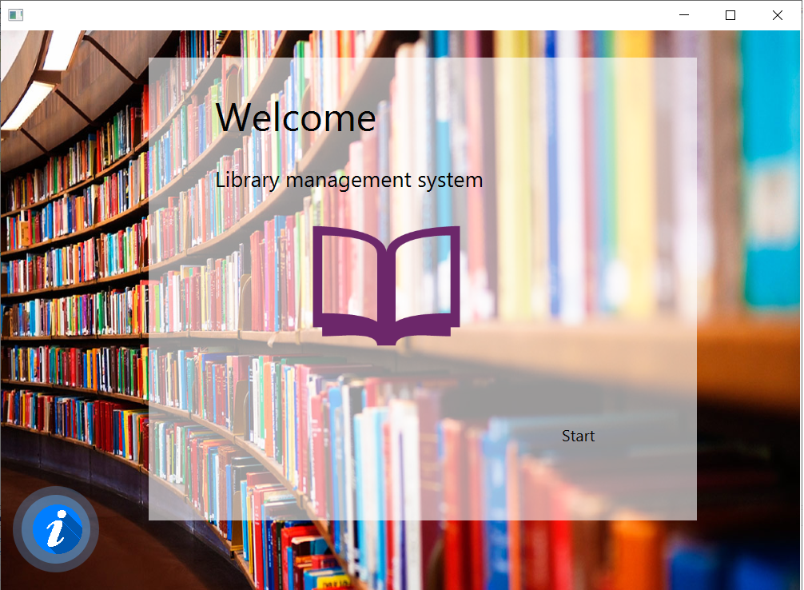

Welcome Screen

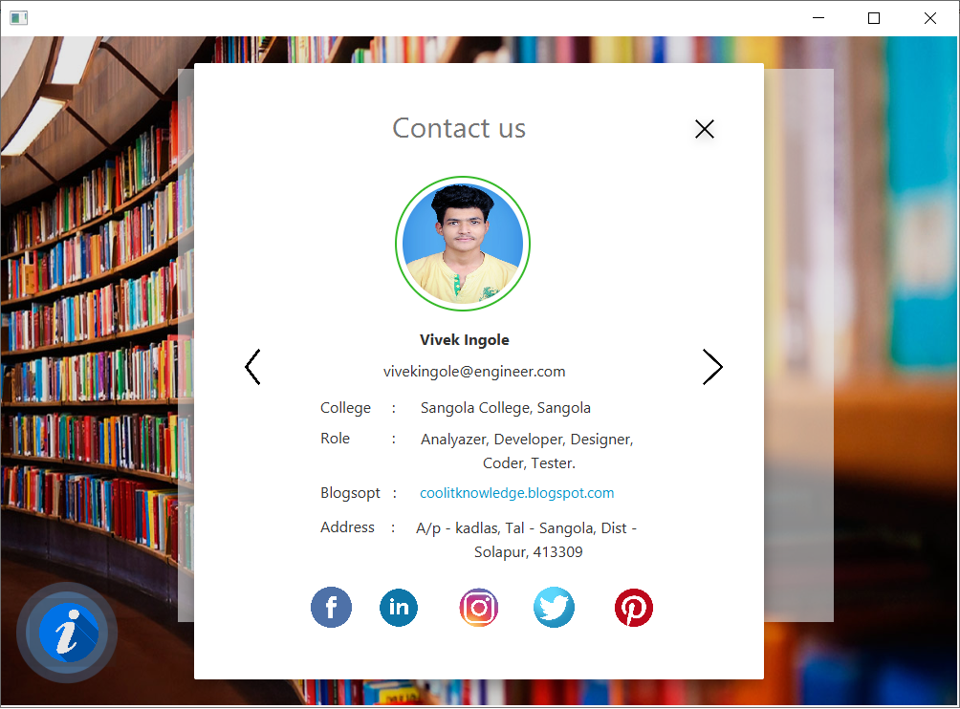

Contact us page

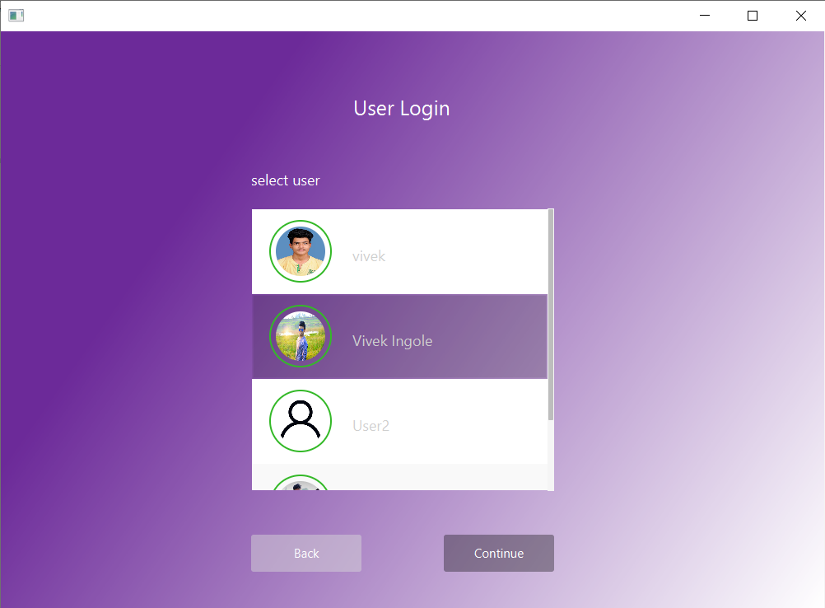

Available User List

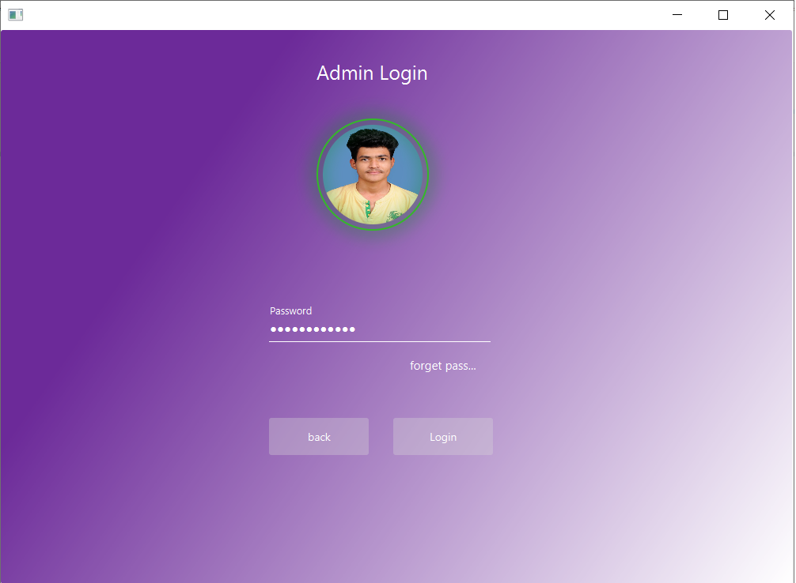

Login Page

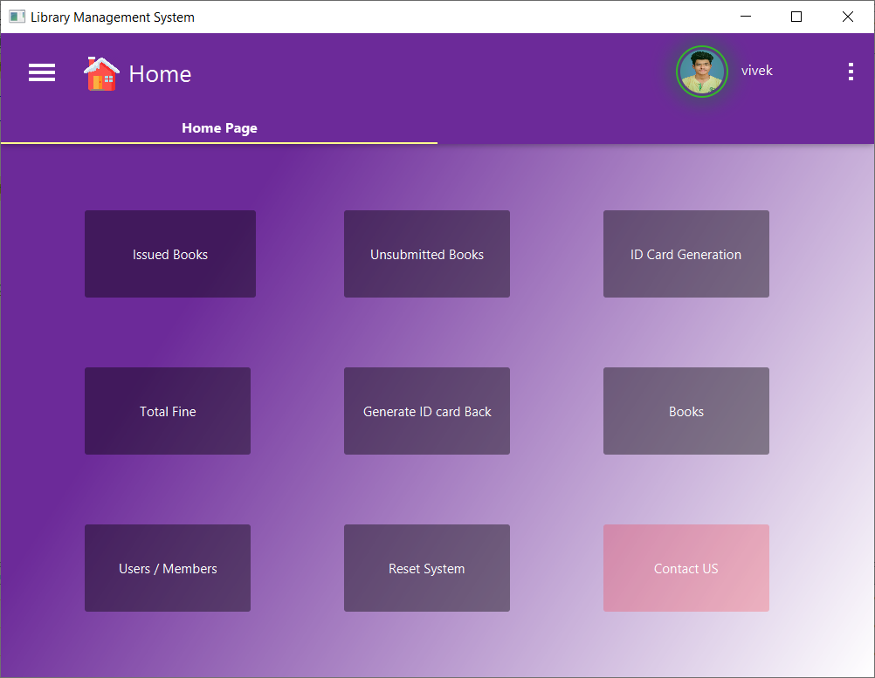

Home Screen

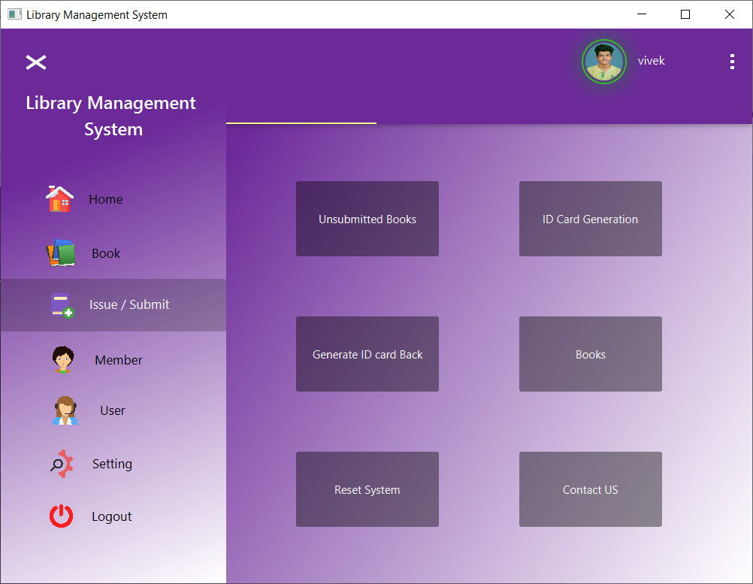

Side Menu

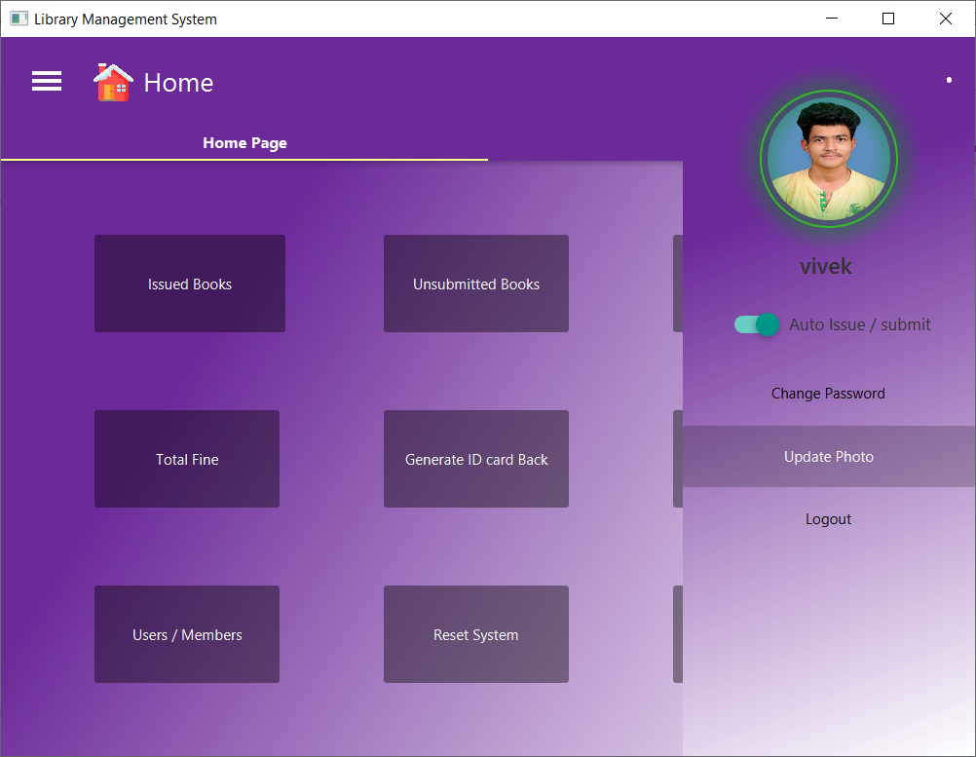

User Menu

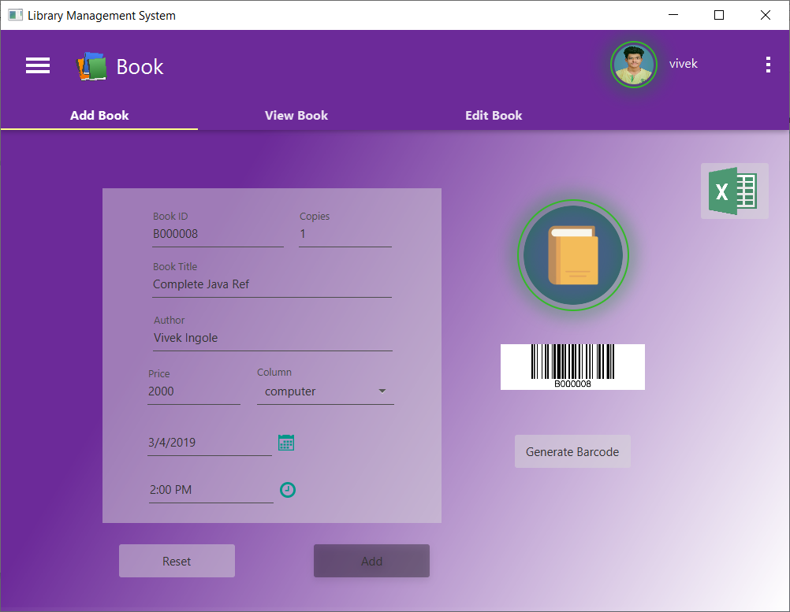

Add Book

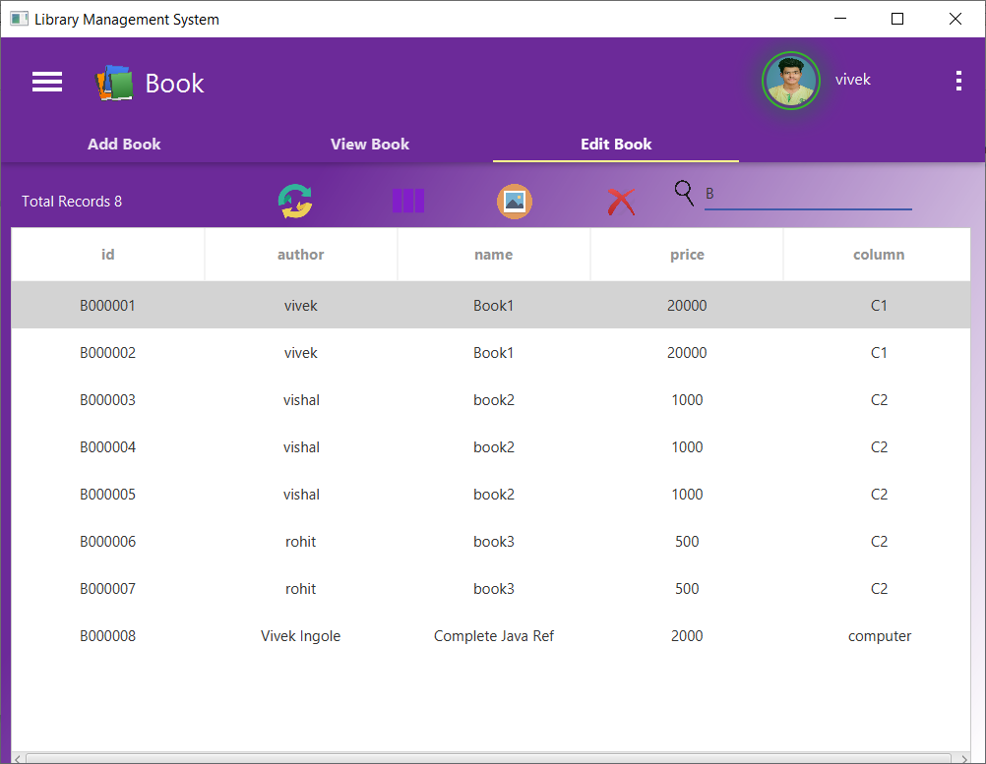

Edit Book

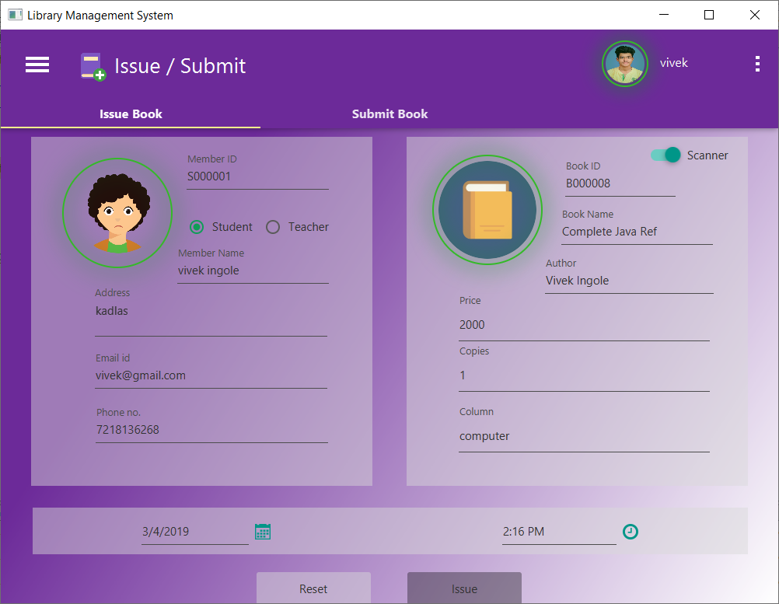

Issue Book

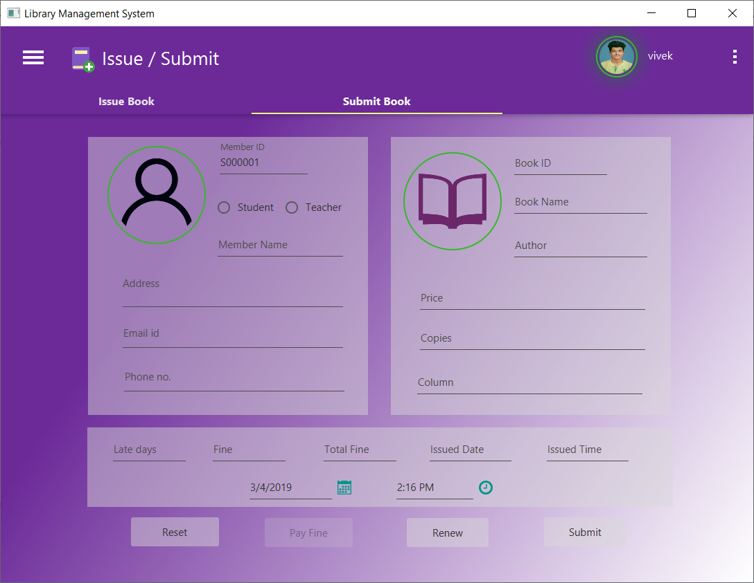

Submit Book

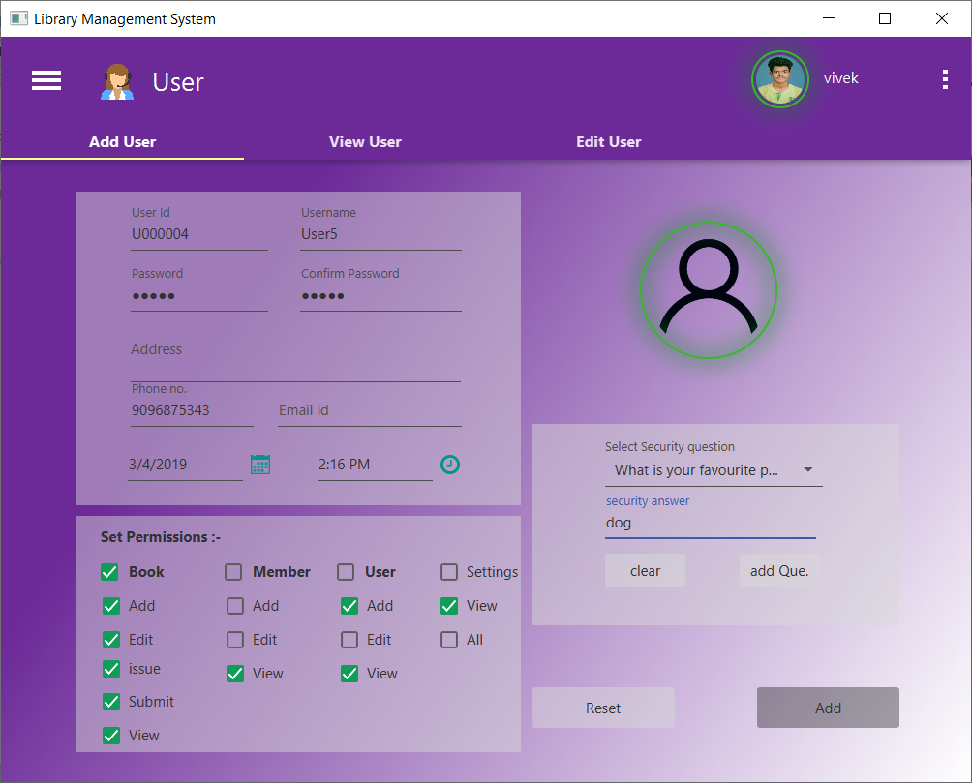

Add New User

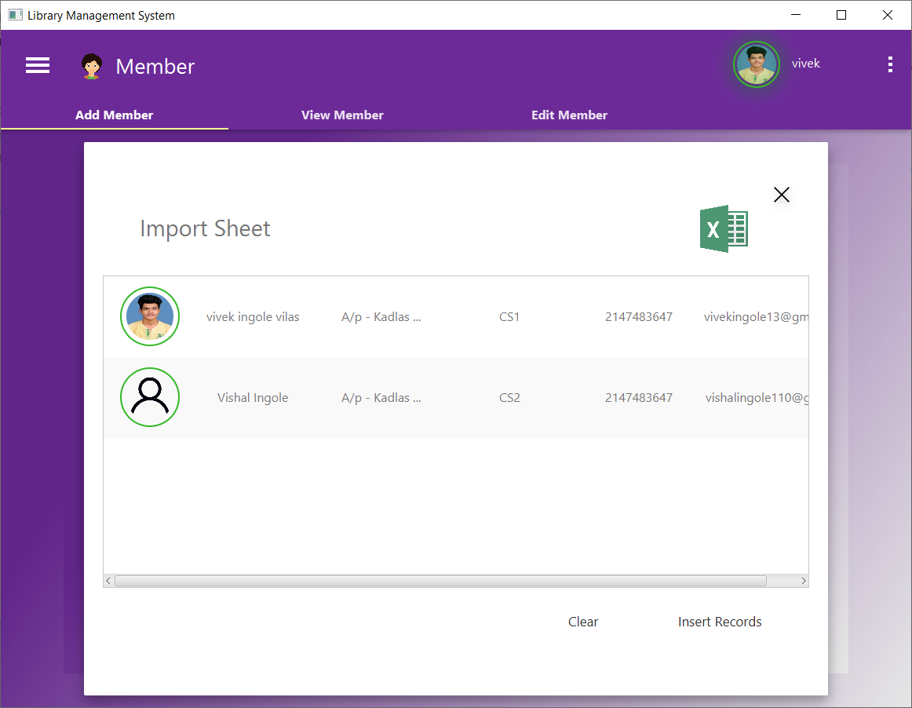

Data Importing through Excel Sheet

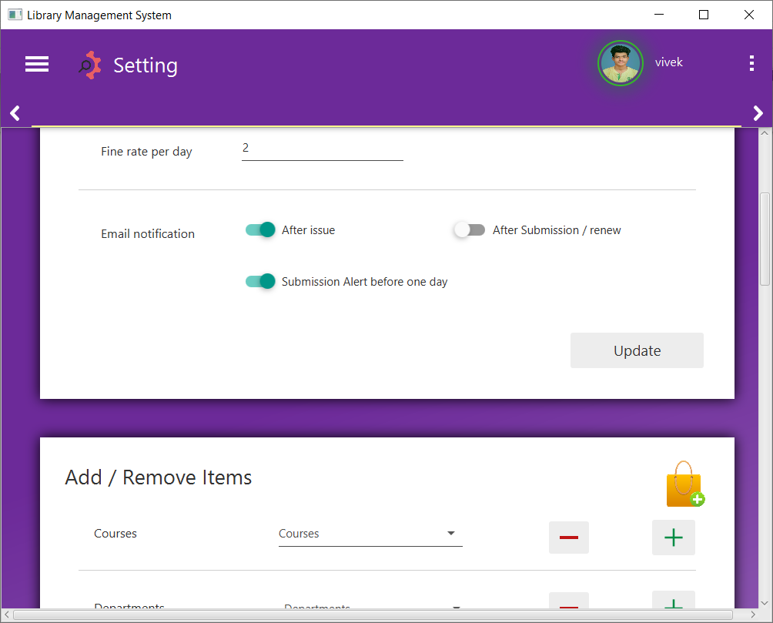

System Setting

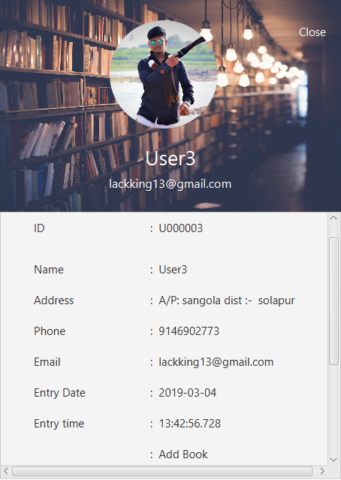

User Details

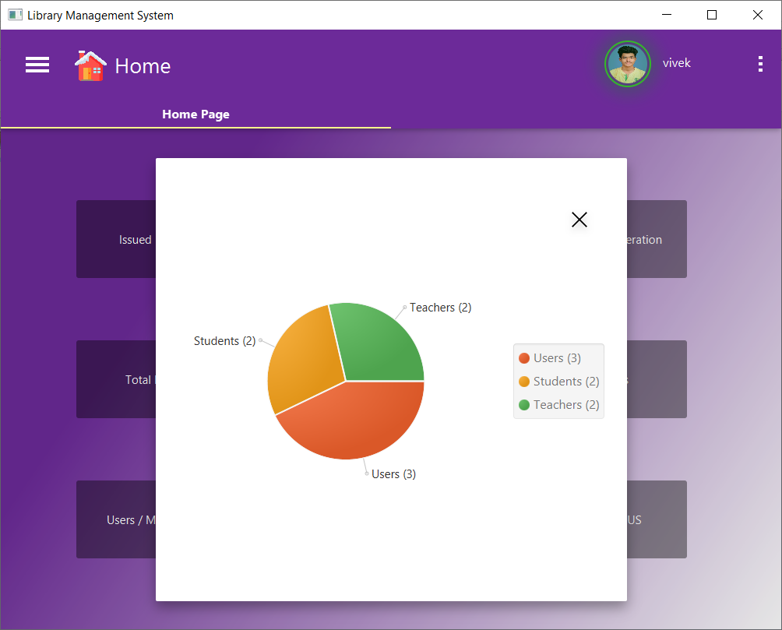

Total User / member Report

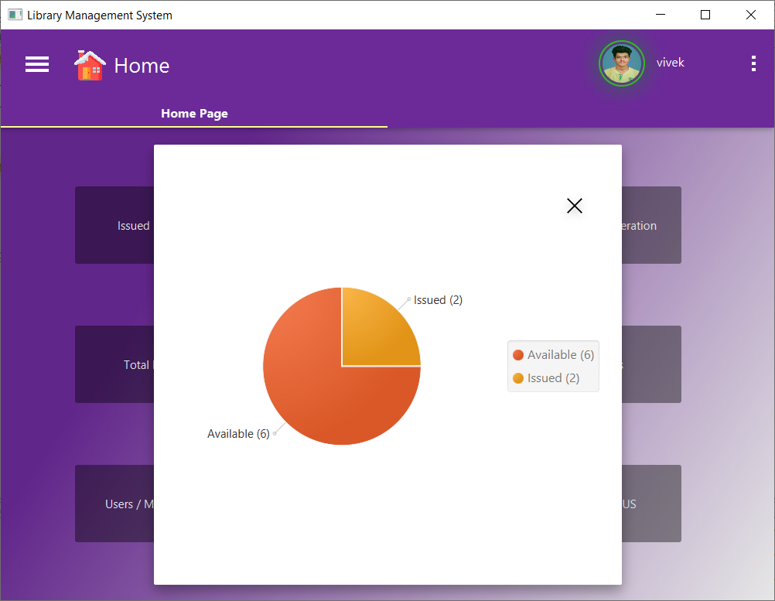

Book Report

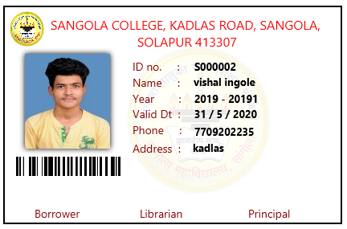

Sample ID Card

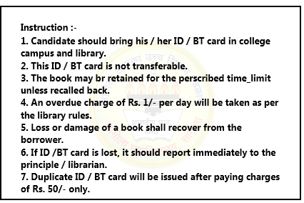

ID Card Backside

*Source Code*

Here you can download complete source code : -

Project Link : -

1. <https://drive.google.com/open?id=17E7-cZpJg4npdhlT1xCMb68njSzeX1bb>
2. <https://coolitknowledge.blogspot.com/p/javafx-projects.html>

Or

Visite Website : - [coolitknowledge.com](coolitknowledge.blogspot.com)

*Output*

This system will be able to generate different kinds of reports motioned below :

* List of Books that have not submitted yet or books is in delayed.
* List of all books that issued to members.
* Generate report for Total fine through out whole year per member.
* Generate Member ID Card according to details that stored in database.
* Generate Graphical report for total users / member count with the help of piechart.

*Advantages*

* User does not need to maintain records manually all this tasks are becomes automated.
* Because of barcoding technique searching process becomes faster.

So user can search any record within constant time.

* Various kind of reports are generated by the system.
* All members of the system get notified time to time about any renew delay, as well as there monthly fine summery.
* We can also assign permissions to each user.
* System maintains security by password encryption.
* This system uses better user interface so every one can easily able to handle the system.

*Future Enhancement*

1. We will improve the security of the system by implementing RFID technology. This chip helps help us to find book if it is lost anywhere as well as to help new librarian to locate the book easily. Another use of this technology is we can easily detect, if anyone leaves library without issuing book. In that case system beeps alert sound to librarian. this feature needs 3D model of library.
2. We also work to provide better UI as well as we add more themes so user can easily handle the system.
3. We also work to implement 3D structure of library. This structure will use by system to give complete path of that book from any location, so user can easily find exact location of any book. This 3D model will use by RFID model to visualize location.

*Limitations*

* This system requires third party software to hide project data folder. Because this system stores all data images into file system so if some ones edit or delete that file may crash the system.
* You can generate only 6 digit barcodes. It cannot be generate more than that.
* This system cannot maintain users login sessions. We just maintain users login time and not calculate their whole login duration ( till logoff ).
* This system may slow down in such computers having low RAM or weak processor.
* Once we generate barcode for particular book or member cannot be updated.

*Bibliography*

For the completion of the ***“Library Management System”*** and documentation we have referred the following resources…

* Java black book – written by nageshwararao.
* Internet :
* Website :Mysirg, stackoverflow, quora, github.
* Youtube channels : programming knowledge, genuine coder, genius coder, mysirg, darkcode, ram Alapure, keepToo.